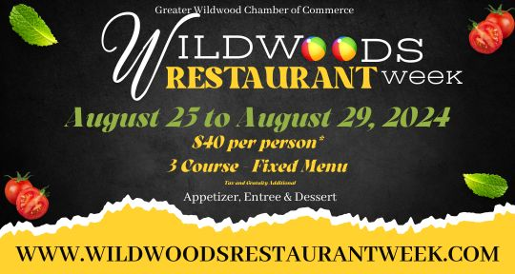
Please note that Alfe’s Restaurant is offer 5 course meal for $40 per person.


First Course Choice Of:
Pasta Fagioli
Fried Calamari
Egg Plant Parmigiana
Bruschetta
Fried Ravioli
Second Course:
House Salad
Third Course:
Intermezzo
Fourth Course Choice Of:
Shrimp Scampi: fresh shrimp bathed in our famous scampi sauce served over a bed of linguini
Chicken Parmigiana: chicken cutlet breaded and pan fried then topped with cheese and gravy
Fettuccine Alfredo: fettuccini served with a creamy homemade alfredo sauce
Grouper: grilled or blackened served with a baked potato
Chef’s Tour of Italy: ravioli, gnocchi, stuffed shell, spaghetti, meatball and sausage
Filet Marsala: petite filet cooked to your preferred temperature then sauteed with mushrooms in a marsala wine sauce
Seafood Marinara: shrimp, scallops, clams, mussels, and calamari sauteed in our marinara served over linguini
Chicken Jacki: boneless breast of chicken sauteed with shrimp, scallops, crab meat in a white wine lemon butter sauce topped with tomato and basil
Fifth Course:
Specialty Ice Cream

