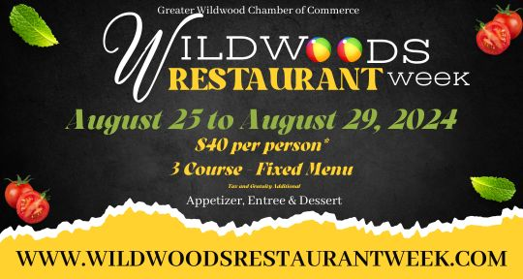**Please note that Alfe’s Restaurant is offer 5 course meal for $40 per person.**

 **First Course Choice Of:**

Pasta Fagioli Fried Calamari Egg Plant Parmigiana  
 Bruschetta  
 Fried Ravioli

**Second Course:**House Salad

**Third Course:**  
Intermezzo  
  
**Fourth Course Choice Of:**Shrimp Scampi: fresh shrimp bathed in our famous scampi sauce served over a bed of linguini

Chicken Parmigiana: chicken cutlet breaded and pan fried then topped with cheese and gravy

Fettuccine Alfredo: fettuccini served with a creamy homemade alfredo sauce

Grouper: grilled or blackened served with a baked potato

Chef’s Tour of Italy: ravioli, gnocchi, stuffed shell, spaghetti, meatball and sausage

Filet Marsala: petite filet cooked to your preferred temperature then sauteed with mushrooms in a marsala wine sauce

Seafood Marinara: shrimp, scallops, clams, mussels, and calamari sauteed in our marinara served over linguini

Chicken Jacki: boneless breast of chicken sauteed with shrimp, scallops, crab meat in a white wine lemon butter sauce topped with tomato and basil  
 **Fifth Course:**Specialty Ice Cream